**COMSATS University, Islamabad**

**Department of Computer Science**

**Assignment 3**

**CSC475: Numerical Computing CLO-4**

**Question # 1:**

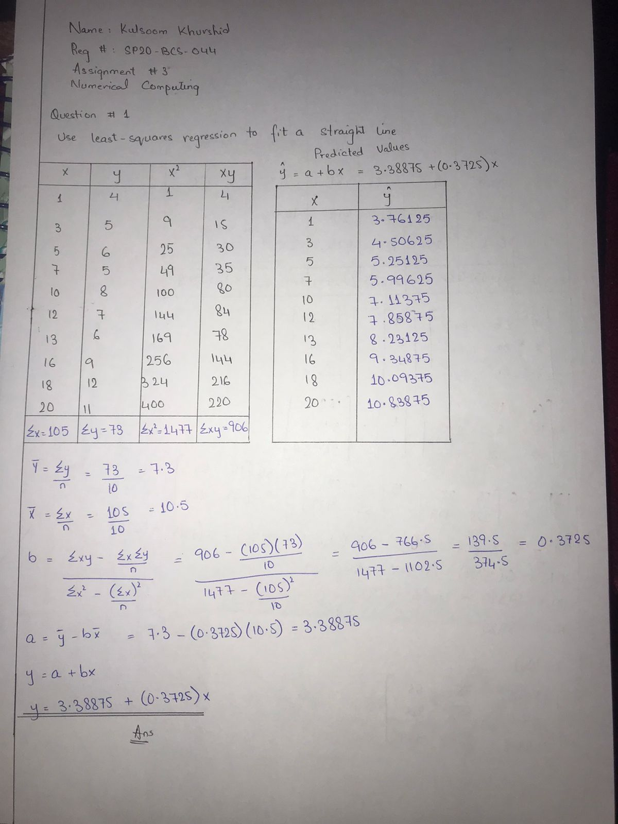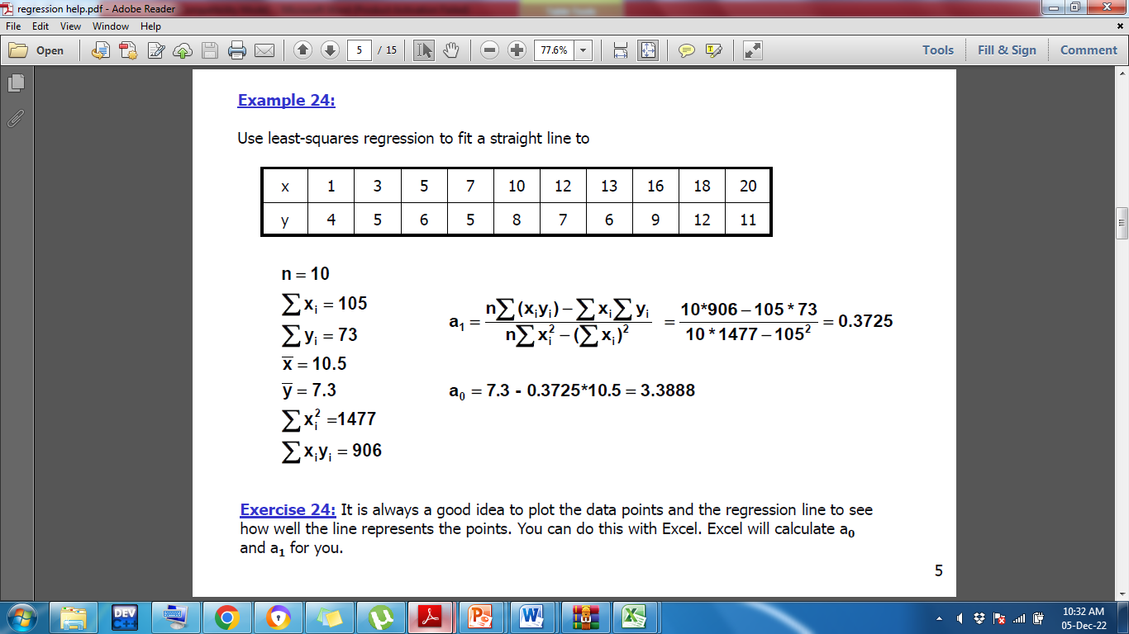

**Question # 2:**

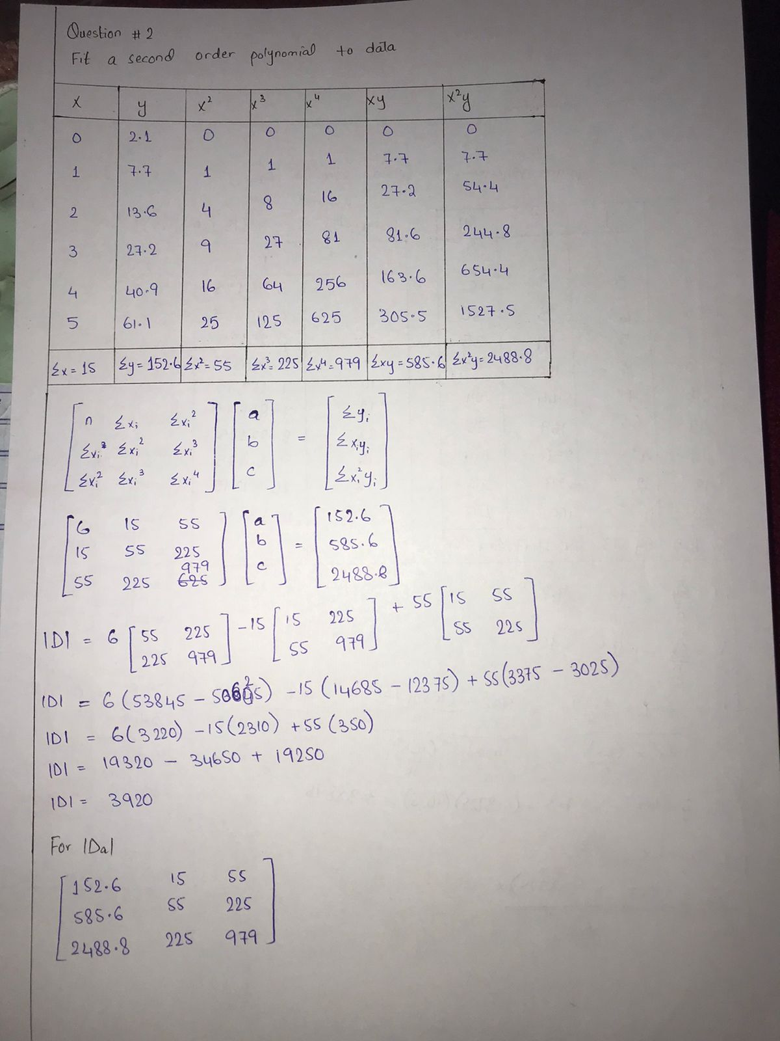Fit a second order polynomial to data:

|  |  |  |  |  |  |  |
| --- | --- | --- | --- | --- | --- | --- |
| x | 0 | 1 | 2 | 3 | 4 | 5 |
| y | 2. 1 | 7.7 | 13.6 | 27.2 | 40.9 | 61.1 |

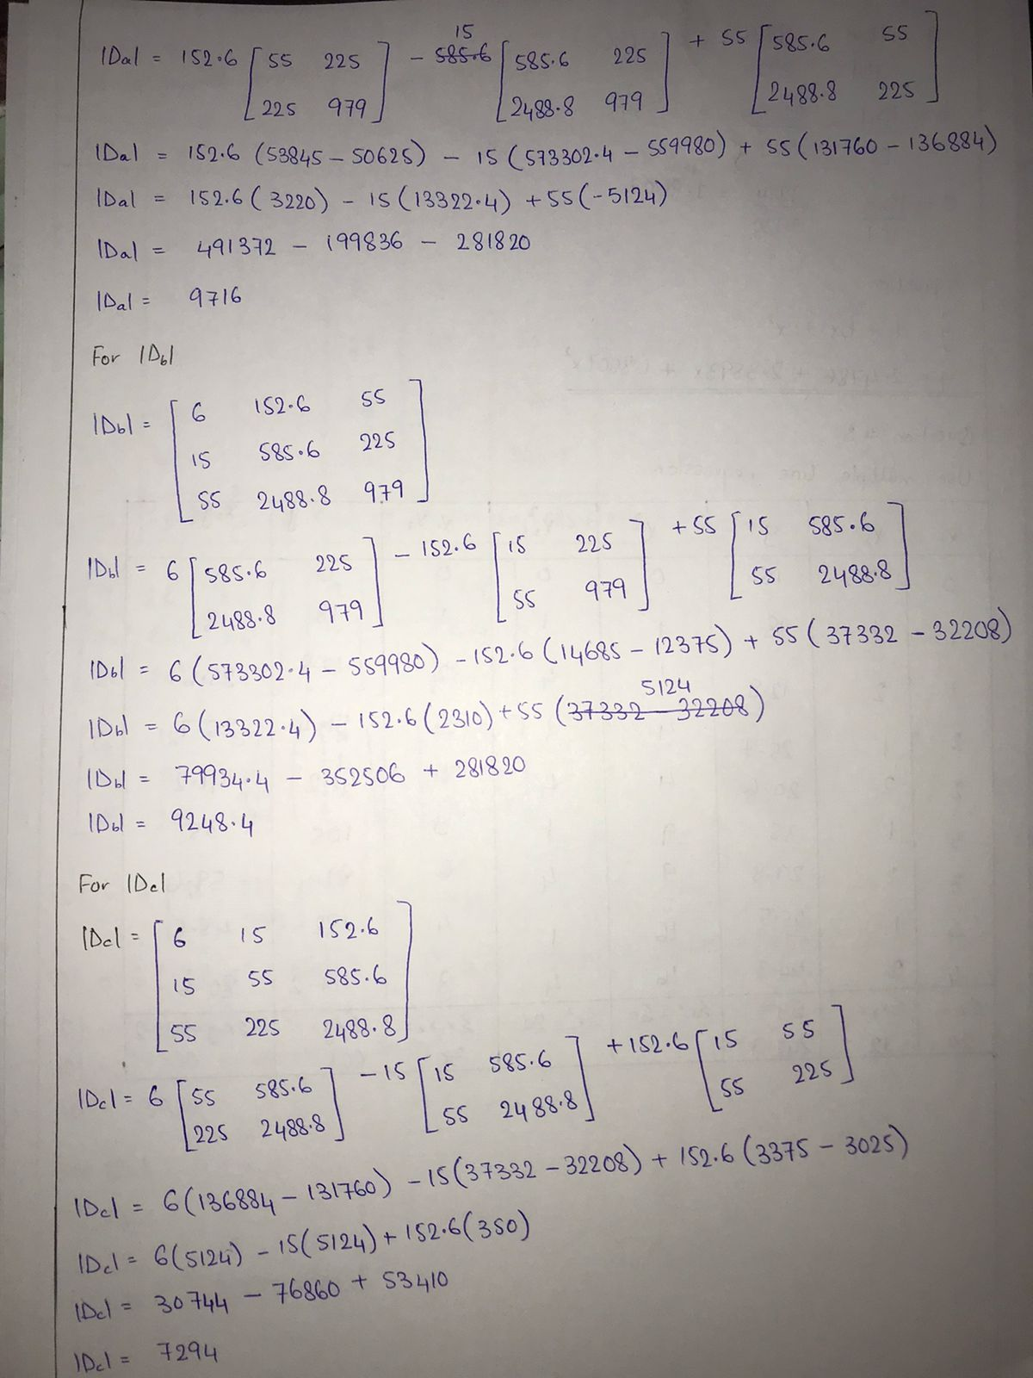

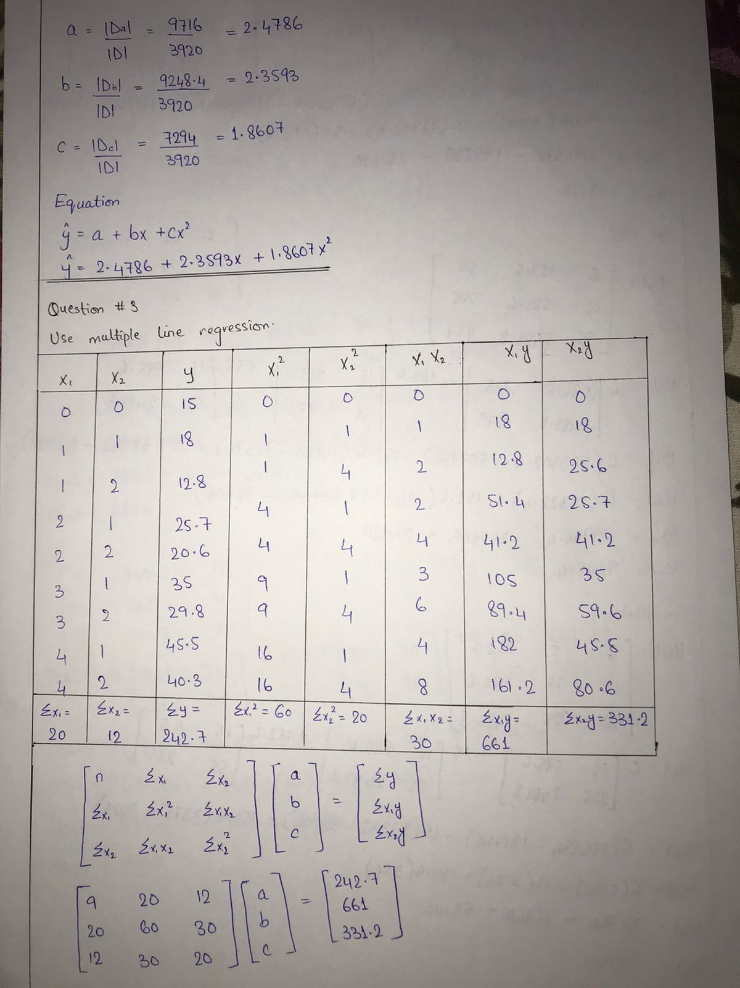

**Question # 3:**

